Deploy Application Using Chef

**Step 1:**

knife cookbook create nexuspull

**Step 2:**

Add below content in default.rb

remote_file '/var/lib/tomcat7/webapps/Realtime.war' do

source '<http://192.168.99.1:8082/nexus/service/local/artifact/maven/redirect?r=snapshots&g=in.javahome&a=myWeb&v=LATEST&e=war>'

end

Change to Your IP address

Try to access below URL:

<http://192.168.99.1:8082/nexus/service/local/artifact/maven/redirect?r=snapshots&g=in.javahome&a=myWeb&v=LATEST&e=war>

Observe that one war file will be download.

**Step 3:**

Install chef identity plugin in Jenkins

goto-->manage jenkins→ manage plugins→ [Chef Identity Plugin](http://wiki.jenkins-ci.org/display/JENKINS/chef-identity+plugin)

Goto →Configure System→ Provide Below details

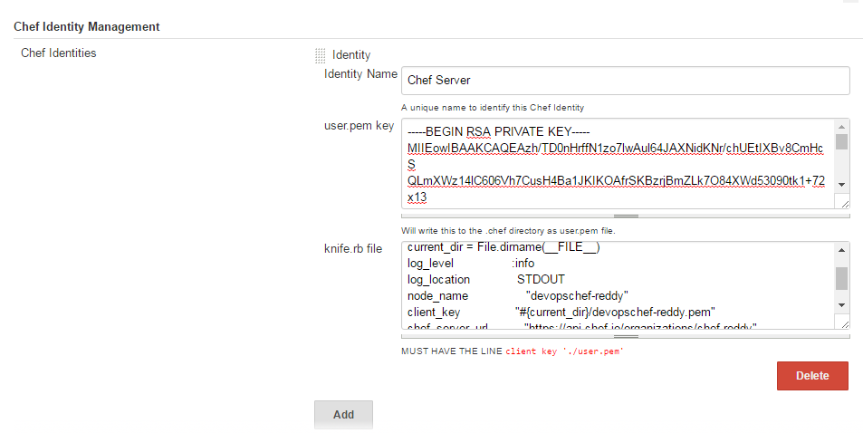

**Step 4:**

Configure the job

job name: Deploy Application Using Chef